North Tyneside Locality Newsletter
Winter 19/20

Early Help….Mission Impossible Made Possible!

Even a Pandemic can’t stop us! Like schools, health and others we continue to be in work, supporting families in need by visiting them, where it is safe to do so, and offering help, advice and practical assistance.

The Riverside Ready for School Centre has been available throughout the year, extending their offer to support families who needed the provision. As we are unable to physically run groups for parents and children due to lockdown/tier 4 restrictions, we have delivered activity packs to families and ran virtual sessions via Facebook, which included storytelling and arts and crafts; (see RFS or the Childrens Centre Facebook pages for regular updates and activities).

We have increased capacity in our Care & Connect service so are able to offer more families that intense, short term, signposting support at the earliest opportunity.

Early Help Assessments and reviews have still been taking place, and in the current climate, are more important than ever, schools have played a vital role in this process which we are grateful for! The Early Help Coordinators are still available to offer support both over the phone and in person should you need them to attend a TAF meeting (please email EarlyHelpAssessments@northtyneside.gov.uk or phone 01916438178)

Early Help partners including Health Visiting, Education rep, Housing, Probation, YOT, Young Carers, Harbour (domestic abuse) have continued to work together as part of the Multi Agency Safeguarding Hub, all be it virtually.

Family Partners and Care & Connect have continue to visit and support families in need. When visiting physically hasn’t been possible they have adapted their support using Teams, phoning, meeting outdoors etc. We know that now more than ever people’s mental health is at a low, in particular children and young people, but we’ve done our best to ensure those children still have a voice and as such have received some brilliant video’s, pictures and activity packs from them, something we’ll continue to do long after COVID. We are making sure all families have face to face visits where needed and children and young people all have the chance to talk on a 1.2.1., face to face basis.

Staff and Managers have all been flexible and happy to work across other service areas when it was required, learning new skills in the process…. So, don’t be confused if you have seen some of us in other roles for a short period of time.

Sadly, though we have said goodbye to Julie Connolly, who was successful in securing a manager post within another part of Children’s Social Care. We wish her all best and will miss her in Early Help. However, we are pleased to welcome Christine McMillan to the South West Locality Managers post; as well several new team members across Early Help, that some of you will already have met.

Admin have continued to support the teams across the service, Riverside Children’s Centre has remained open, operating with COVID safe measures in place, to ensure front line staff could continue to use it…. Plus, we’ve still managed to deliver a huge number of Birth Registrations!

And finally, thank you for your continued support! We know you have a difficult job and have continued to brave the front line during what has been a challenging time for everyone, we appreciate and value your contribution and the collaborative relationships we’ve been able to maintain over the past year. Let’s continue working together to support our families into a better 2021! Onwards and upwards!

Early Help Pathway

Following the review of the Locality meetings and developments within the MASH, we have updated the Early Help Pathway to reflect the changes. See flow-chart below which gives further guidance in relation to the graduated response to Early Help.

Both documents can also be found on the Council website.

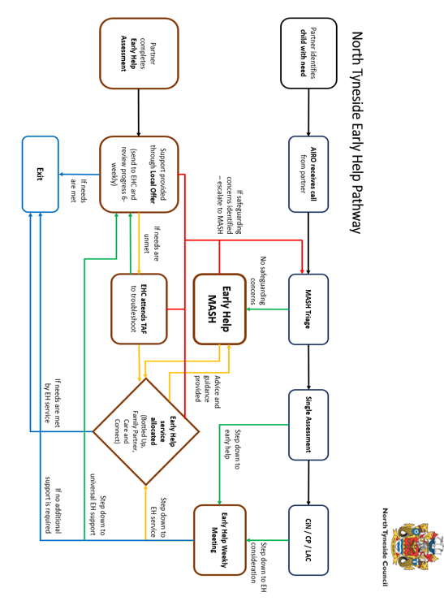
Please let us know if you want to know more about anything in the North Tyneside
0-19 world and we’ll see what we can do!

We hope you found this newsletter interesting – if you’d like to contribute any Localities news please get in touch with a Locality Manager, or email us at:

SupportingFamilies@northtyneside.gov.uk.

